GreenTwins information model: Object types and parameters in the GreenTwins plant library

Introduction
This specification defines attributes of vegetation objects in the GreenTwins algorithmic plant library. The document defines the format in which GreenTwins vegetation data is stored in databases, provides details of the content and usage of parameters for interoperability purposes, and describes linkages and similarities to the Vegetation CityGML ADE definition [1].

GreenTwins plant library information model
The GreenTwins plant library consists of four types of vegetation objects:
Locations and characteristics of urban vegetation are described using the spatial objects Individual plants and Plant covers. Individually planned and placed large plants are modelled as Individual plants, whereas areas populated by spontaneously growing vegetation and e.g. herbaceous plants are modelled as Plant covers. Individual plant and Plant cover object classes are designed as extensions of the CityGML Vegetation objects SolitaryVegetationObject and PlantCover.
Individual plants and Plant covers may be linked to non-spatial object classes Species and Plant cover type, respectively. Plant cover types specify the default species composition for Plant covers, and how the species composition of that Plant cover type changes under different kinds of management. Individual plants may be linked to a non-spatial object class Species, which defines how Individual plants of the Species grow and are visualised in a digital twin. Besides multi-year species that can be modelled as Individual plants, Species may also be defined to contain visualisation data for herbaceous plants that may appear in Plant covers.

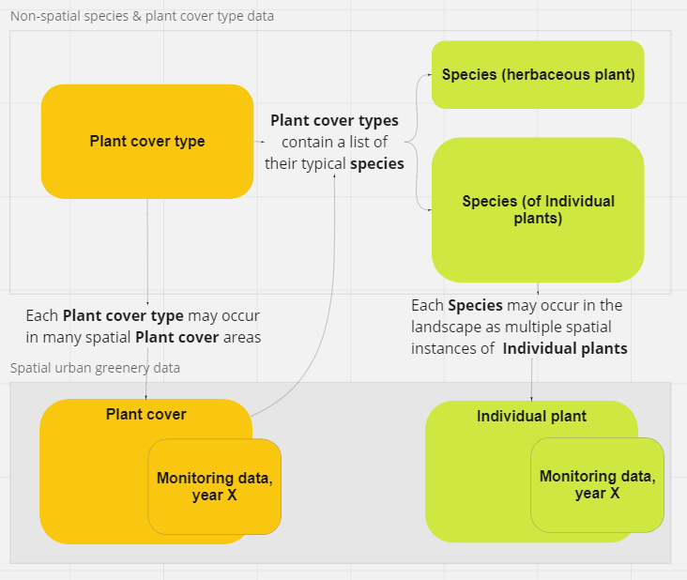

Species
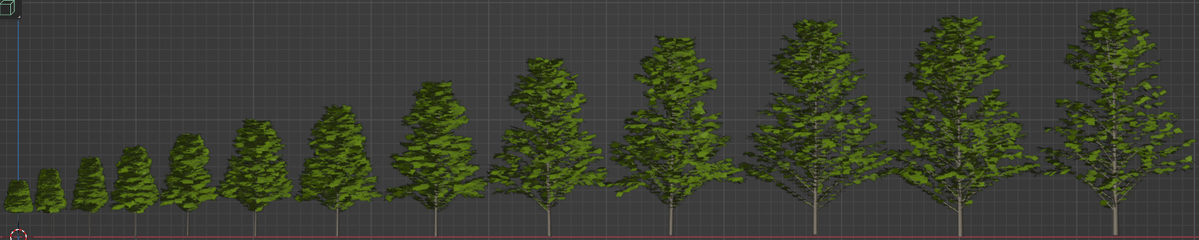
Figure 1: Example of a plant 3D model growth according to age-dependent growth curves of the species (height, stem diameter, stem height, crown width).

Species definitions may exist both for multi-year species aka trees or shrubs that are modelled as Individual plants gor as part of species of Plant covers/Plant cover types, and for annual herbaceous plants that may be modelled only as part of Plant covers/Plant cover types. Fields that are designed for modelling Individual plants (trees and shrubs) or only for Herbaceous plants are marked with a [X] in the respective columns.

GreenTwins example implementation:
- Species and habitat site type database RestAPI IP: http://217.146.76.238:3000/
- Documentation about the API: PostgREST Documentation — PostgREST 9.0.0 documentation
- Database structure diagram: https://dbdiagram.io/d/63b2c2a07d39e42284e87015

Naming/taxonomic attributes:
Parameter | Definition | Required | N (*) | Content & format | Individual plants (trees and shrubs) | Herbaceous plants
Species code | - The projection algorithm will use the species code to map Individual plants with this species codes to the growth model of the respective Species object. If growth data for the species does not exist in the Species database, the algorithm will look for another species in the same Family or Growth type.  - GreenTwins applications will use the species code to look for species visualization files (e.g. bark texture and 3D twigs) in the respective Species object.  - Note: The GreenTwins project did not develop a proposal for an extensive coding system for species. Codes to be developed should (a) be extensible to new species without braking the logic of the coding system, (b) preferably have hierarchy, so that from the species code, it would be possible to infer codes of higher taxonomic levels and (Species, Family, Genus). Species codes should also be different for different varieties of the same species. | Yes | 1 | Integer (4 digits) / ArcGIS short datatype  Content:  CityGML 2.0 C.7 Vegetation module code list for species | X | X
Genus |  | No | 1 |  | X | X
Species/interspecies hybrid/sub-species/variety/form |  | No | 1 |  | X | X
Cultivar/hybrid of cultivars |  | Yes | 1 |  | X | X
Class | - The projection algorithm will use the growth form of plants to find a closest suitable growth model, in case species data does not exist, or if only the growth form is defined for a planned plant. See examples on the right in the CityGML description. | Yes | 1 | Integer (4 digits) / ArcGIS short datatype  Content:  CityGML code 2.0 C.7 Vegetation module code list for class (e.g. shrub, low plants, medium high plants, high plants, grasses, ferns, coniferous tree, deciduous tree, shrubs, aquatic plants, climber, unknown) | X | X
English name | For family, species...,cultivar... in separate table | No | 1 |  | X | X
Estonian name | For family, species...,cultivar... in separate table | Yes | 1 |  | X | X
Finnish name | For family, species...,cultivar... in separate table | Yes | 1 |  | X | X
Creator |  |  |  |  | X | X
Creator timestamp |  |  |  |  | X | X
Editor |  |  |  |  | X | X
Editor timestamp |  |  |  |  | X | X

Visualization, trees and shrubs:
Note: As the GreenTwins plant library generates plant 3D models algorithmically according to the needed plant age, Level-of-Detail and individual variation, it should be possible to store the graphical components needed for the algorithmic compilation of Species 3D models in the Species module. However, the implementation could be flexible so that additional files can be added for specific plant models where needed. The list below should be considered as examples.
Parameter | Definition | Required | N (*) | Content & format | Trees and shrubs | Herbaceous plants
Leaf texture atlas, color | PNG file (RGB map, also the terms albedo map, diffuse map or main texture are used for this, the *ONE* texture you really need), used for LoD0 twig | No | N | Link or image file | X
Leaf texture atlas, opacity | PNG file (quite similar to alpha map or transparency map), used for LoD0 twig |  |  |  | X
Leaf texture atlas, normal | PNG file, used for LoD0 twig |  |  |  | X
Twig branch texture, color | PNG file (RGB map, also the terms albedo map, diffuse map or main texture are used for this, the *ONE* texture you really need), used for LoD0 twig |  |  |  | X
Twig branch texture, opacity | PNG file (quite similar to alpha map or transparency map), used for LoD0 twig |  |  |  | X
Twig branch texture, normal | PNG file, used for LoD0 twig |  |  |  | X
Trunk texture, color | PNG file (RGB map, also the terms albedo map, diffuse map or main texture are used for this, the *ONE* texture you really need), used for LoD0 twig |  |  |  | X
Trunk texture, opacity | PNG file (quite similar to alpha map or transparency map), used for LoD0 twig |  |  |  | X
Trunk texture, color | PNG file, used for LoD0 twig |  |  |  | X
Baked LoD1 texture, color | PNG file (RGB map, also the terms albedo map, diffuse map or main texture are used for this, the *ONE* texture you really need), used for LoD0 twig |  |  |  | X
Baked LoD1 texture, opacity | PNG file (quite similar to alpha map or transparency map), used for LoD0 twig |  |  |  | X
Baked LoD1 texture, normal | PNG file, used for LoD0 twig |  |  |  | X
Impostor atlas, color | PNG file (RGB map, also the terms albedo map, diffuse map or main texture are used for this, the *ONE* texture you really need), used for LoD3 in VGP |  |  |  | X
Impostor atlas, opacity | PNG file (quite similar to alpha map or transparency map), used for LoD3 in VGP |  |  |  | X
Impostor atlas, normal | PNG file, used for LoD3 in VGP |  |  |  | X
Plant billboard, color | (As a backup for impostors, if an open-source impostor shader does not come available.)
Plant billboard, opacity | (As a backup for impostors, if an open-source impostor shader does not come available.)
Plant billboard, normal | (As a backup for impostors, if an open-source impostor shader does not come available.)
ADD SEASONAL VARIANTS OF BILLBOARD IMAGES
LoD0 twig 3D model file | FBX file |  |  |  | X
LoD1 twig 3D model file | FBX file |  |  |  | X
Date of leaf outbreak | Date field | No | 1 | Date field | X
Date of autumn colours | Date field | No | 1 | Date field | X
Date of leaf fall | Date field | No | 1 | Date field | X
(Date of flower appearance?) |  | No |  |  | X
(Date of fruit appearance?) |  | No |  |  | X
(End date of flowers/fruits) |  | No |  |  | X
Leaf RGB colour spring | Antti uses | No | N | Character string (length 9 characters) | X
Leaf RGB colour autumn | Antti uses, needs more input from Andres | No | N | Character string (length 9 characters) | X

A table of ready-made 3D models of different age & seasonal versions & LoD levels:
Parameter | Definition | Required | N (*) | Content & format | Trees and shrubs | Herbaceous plants
 | Naming convention used to define which models are stored | No | N | Link | X

Visualization, herbaceous plants:
Parameter | Definition | Required | N (*) | Content & format | Trees and shrubs | Herbaceous plants
Spring image, colour map |  | No | 1 | Link or image file |  | X
Spring image, opacity map
Spring image, normal map
Summer image, colour map |  | No | 1 | Link or image file |  | X
Summer image, opacity map
Summer image, normal map
Autumn image, colour map |  | No | 1 | Link or image file |  | X
Autumn image, opacity map
Autumn image, normal map
Winter image, colour map |  | No | 1 | Link or image file |  | X
Winter image, opacity map
Winter image, colour map
Billboad size | Height & width
Spring date |  | No | 1 | Date file |  | X
Summer date |  | No | 1 | Date file |  | X
Autumn date |  | No | 1 | Date file |  | X
Winter date |  | No | 1 | Date file |  | X

Dimension growth curves – a table of following parameters:
The GreenTwins information model stores and projects the growth of plants in four dimensions: Height, stemHeight, stemDiameter and crownDiameter. The following items may appear as a sub-table, which may contain one or many rows of the attributes below.
Parameter | Definition | Required | N (*) | Content & format | Trees and shrubs | Herbaceous plants
Age in years |  | Yes | N |  | X
stemDiameter at age |  | Yes | N |  | X
Height at age |  | Yes | N |  | X
crownDiameter at age |  | Yes | N |  | X
stemHeight at age |  | Yes | N |  | X

Dimension data, trees and shrubs:
Parameter | Definition | Required | N (*) | Content & format | Trees and shrubs | Herbaceous plants
Typical planting size/age | - The projection algorithm will use this size/age for planned plants at the start of the growth simulation. | Yes | 1 |  | X
Full-grown size/age | - The projection algorithm will use this size/age for plants in empirical data (e.g. city records) for which only the species is known, but age/size data is missing. |  | 1 |  | X
Date of growth data | - The projection algorithm uses a time stamp to check if the fitted projection model is up-to-date or needs to be updated |  | 1 |  | X
Default species | X
Default species of class | X
Default species of genus | X
Planting distance category

Fitted parameters:
NOTE: The GreenTwins plant library automatically fits sigmoid growth curves for plants based on given age-based dimensions, to allow estimating plant sizes for any time point. Each fitted growth curve for a particular dimension contains three parameters (1 to 3).The list of resulting parameters for projecting plant growth should be taken as an example only, e.g. parameter names can be rendered more descriptive.
Parameter | Definition | Required | N (*) | Content & format | Trees and shrubs | Herbaceous plants
a1 |  | No | 1 |  | X
a2 |  | No | 1 |  | X
a3 |  | No | 1 |  | X
b1 |  | No | 1 |  | X
b2 |  | No | 1 |  | X
b3 |  | No | 1 |  | X
c1 |  | No | 1 |  | X
c2 |  | No | 1 |  | X
c3 |  | No | 1 |  | X
d1 |  | No | 1 |  | X
d2 |  | No | 1 |  | X
d3 |  | No | 1 |  | X
Fitting date |  | No | 1 | Date field

Additional data (planned future extensions):
- Environmental requirements
- Planting space / root space
- Ecosystem Service/Green Area Factor calculation values?
- Biodiversity effects
- Phenology data (yearly tracking of seasonal changes)
- Public user interface for viewing Species info

Individual plant
Individual plants are extensions of a CityGML class SolitaryVegetationObject, which derives attributes from a _CityObject. Individual plants may appear in the GreenTwins plant library in three forms:
- For current vegetation/empirical data, it is possible to record plant object ages and sizes at the year/time point when they were (last) surveyed,
- For planned vegetation, data on plant dimensions is not relevant, as the plants do not exist in real life yet. Additionally, (sub-)species or varieties of planned vegetation may not have been determined yet, in which cases it is possible that only the class of vegetation is recorded,
- Projections present the projected ages and dimensions of the current/empirical or the planned vegetation at the given projected year in the future.

GreenTwins examples:
- Toompark trees point data: https://services3.arcgis.com/FwX2qF9JecNSRnwr/arcgis/rest/services/Toompark_inventeerimine/FeatureServer
- Hermanninranta trees point data: https://services3.arcgis.com/FwX2qF9JecNSRnwr/arcgis/rest/services/Helsinki_field_inventories_points/FeatureServer

Geometry
Parameter | Field in CityGML | Definition | Required | N (*) | Content & format | Current/empirical | Plans | Projections
XYZ point coordinate | <Object> ImplicitGeometry =>  <Geometry>  gml::Point | An XYZ coordinate that defines the point where the plant’s stem or trunk meets the terrain. If the Z coordinate is missing, the plant is placed at the point of the given XY coordinate at the terrain level. | Yes | 1 | X coordinate: float (10 decimals)  Y coordinate: float (10 decimals)  Z coordinate: float (10 decimals)  Coordinate system:  - Helsinki: ETRS-GK25 (EPSG: 3879), height system N2000  - Tallinn: Estonia 1997 National Grid (3301), height system EH2000, based on EVRS system | x | x | --
Implicit geometry |  | The shape of an ImplicitGeometry can be represented in an external file with a proprietary format. Links plant data to a generic-outlook 3D model and its seasonal appearances. | Yes |  | xlink:href

Data attributes
Attributes derived from CityGML _CityObject:
Parameter | Field in CityGML | Definition | Required | N (*) | Content & format | Current/empirical | Plans | Projections
Planting date | creationDate : <<Feature>> core::_CityObject | CityGML: “[Starts] the time period in which a specific version of an object is an integral part of the 3D city model.” [2] In the GT plant library, the field can be used to record the planned planting date of the plant. For existing trees without a known planting year, age can be estimated and converted to a planting year for simulation purposes. | No | 1 | xs:date | x | x | --
terminationDate | terminationDate : <<Feature>> core::_CityObject | CityGML: “[Ends] the time period in which a specific version of an object is an integral part of the 3D city model”. [2] In GT plant library, this field can be used to record the planned date of plant removal from the landscape. | No | 1 | xs:date | x | x | --
externalReference | externalReference : <<Feature>> core::_CityObject | CityGML: “denotes the external information system and the unique identifier of the object in this system… The generic concept of external references allows for any _CityObject an arbitrary number of links to corresponding objects in external information systems, may contain botanical information from public environmental agencies”. GT plant library uses this field to store the unique ID of the object in the city system where the data was retrieved. | No | N | Uniform Resource Identifier (URI) / String in ArcGIS | x | x | --

Attributes derived from CityGML SolitaryVegetationObject:
Parameter | Field in CityGML | Definition | Required | N (*) | Content & format | Current/empirical | Plans | Projections
Class | class | CityGML: “contains the classification of the object or plant habit, e.g. tree, shrub, grass”. NOTE: The GreenTwins plant library does not consider this field mandatory, as the Species of the Individual plant should rather provide respective data of the Species’ class. | No | 1 | Integer (4 digits) / ArcGIS short datatype  Content:  CityGML code 2.0 C.7 Vegetation module code list for class (e.g. shrub, low plants, medium high plants, high plants, grasses, ferns, coniferous tree, deciduous tree, shrubs, aquatic plants, climber, unknown) | x | X | --
Species code | species | CityGML: “defines the species’ name, for example ‘Abies alba’. NOTE: The species coding system needs further development to provide e.g. guidelines for adding new species. | No | 1 | Integer (4 digits) / ArcGIS short datatype  Content:  CityGML 2.0 C.7 Vegetation module code list for species | x | X | --
Height | height | CityGML: “contains the relative height of the object”. GT plant library defines height in metres. | No | 1 | Floating point number | X | -- | X
trunkDiameter | trunkDiameter | CityGML: “represents the trunk diameter”. GT plant library defines height in centimetres. | No | 1 | Floating point number | X | -- | X
crownDiameter | crownDiameter | CityGML: “represents the plant crown”. GT plant library stores the widest dimension of the plant crown in centimetres. | No | 1 | Floating point number | X | -- | X

Attributes added by the GreenTwins plant library:
Parameter | Field in CityGML | Definition | Required | N (*) | Content & format | Current/empirical | Plans | Projections
Object ID (/Unique ID) | -- | Incremental unique identifier needed for the database struct. UID given when storing a plant in the server. | Yes | 1 | Gml:id | x | x | X
Species name | -- | Species’ scientific name as text. NOTE: The GreenTwins plant library does not consider this field mandatory, as the Species code of the Individual plant should provide access to the detailed definition of the species. | No | 1 | Character string, max length 255 characters | x
Protected | -- | The individual plant is classified as protected in the city systems. | No | 1 | Integer (1 digit)  1 = protected  0 = not protected
randomSeed | <generic> | Used to randomize parts of algorithmic vegetation creation. Storing a plant’s random seed allows recreating the plant. (NOTE: Not implemencted in the GreenTwins impelmentation, but considered a future extension.) | No | 1 | Integer (6? digits)
Data source | -- | May be used in client applications to e.g. display elements differently based on data certainty and type.  If age/size information is missing, the projection algorithm will display plants differently based on this field, e.g. planned plants are expected to be young planted plants at the start of the growth simulation, but plants in empirical data will be expected to be in mature age. | No | 1 | Character string, max length 255 characters | x | x | X
Latest survey year | -- | The year of empirical survey (for empirical data) or projection (for plant projections). If both the planting yeas and the projected year are defined, it is possible to project tree growth from the planting year to the given year. | No | 1 | xs:date | X | -- | x
Projected year |  | The year of projection. If both the planting yeas and the projected year are defined, it is possible to project tree growth from the planting year to the given year. |  |  |  |  |  | X
Stem height, street side | -- | Used for urban planning in Tallinn | No | 1 | Floating point number | X | - | X
Stem height, forest side | -- | Used for urban planning in Tallinn | No | 1 | Floating point number | X | - | (x)
Creator | ? |  | Yes | 1 | Character string, max length 255 characters | x | x | --
Creator timestamp | ? |  | Yes | 1 | xs:date | X | x | --
Editor | ? |  | No | 1 | Character string, max length 255 characters | x | X | --
Editor timestamp | ? |  | No | 1 | xs:date | x | X | --
Plan ID |  | Can be used both for filtering vegetation objects linked to a certain plan, but also to view details of a plan, e.g. planning stage and type

* Whether the object can have one or multiple instances of this field
** Default digital twin is constructed from city databases reflecting the current/recent city data, GreenTwins initiated data collection, and possibly approved city plans that will be incorporated into the default green twin

Plant cover type
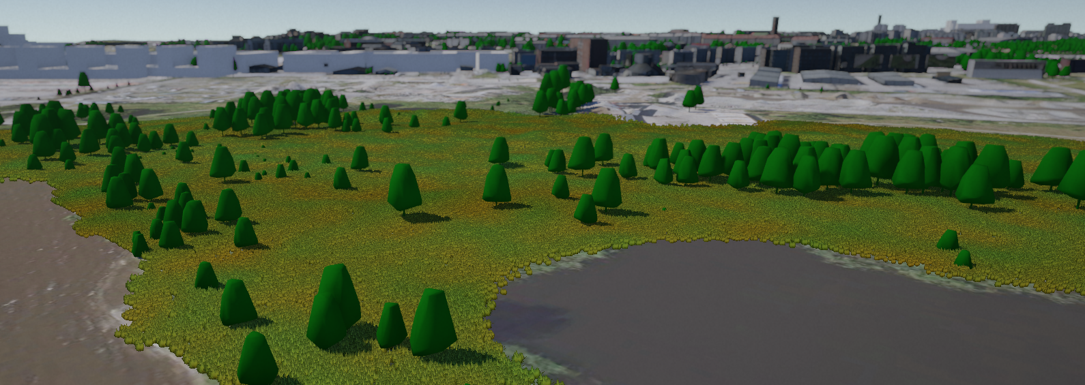
Figure 2:

GreenTwins examples:
- Species and habitat site type database RestAPI IP: http://217.146.76.238:3000/
- Documentation about the API: PostgREST Documentation — PostgREST 9.0.0 documentation
- Database structure diagram: https://dbdiagram.io/d/63b2c2a07d39e42284e87015

Naming/taxonomic attributes:
Parameter | Definition | Required | N (*) | Content & format
Habitat site type class |  | Yes | 1 | string
Habitat site type group |  | No |  | string
Habitat site type |  | No |  | string
Habitat site sub-type |  | No |  | string
Creator | Creator of the database object |  |  | string
Creator timestamp | Timestamp |  |  | date
Editor | Editor of the database object |  |  | string
Editor timestamp | Timestamp |  |  | date
Default maintenance type

Species composition – Trees:
The following items may appear as a sub-table, which may contain one or many rows of each attribute below.
Parameter | Definition | Required | N (*) | Content & format
Species code |  | Yes | N | Integer (4 digits)  EPPO codes for the GreenTwins species list
Species cover % | Percentage of species cover on the site, i.e. how much of area the species covers if looking from above (e.g. trees with wide crowns have higher cover per individual than trees with narrow crowns). | Yes | N
Age class | Age classes, e.g. 0-20, 20-60 years, 60-, not known. NOTE: Only meaningful for woody plants (trees and shrubs) | No | N

Species composition – Shrubs/Shrubs:
The following items may appear as a sub-table, which may contain one or many rows of the attributes below.
Parameter | Definition | Required | N (*) | Content & format
Species code |  | Yes | N | Integer (4 digits)  EPPO codes for the GreenTwins species list
Species cover % | Percentage of species cover on the site, i.e. how much of area the species covers if looking from above (e.g. trees with wide crowns have higher cover per individual than trees with narrow crowns). | Yes | N
Age class | Age classes, e.g. 0-20, 20-60 years, 60-, not known. NOTE: Only meaningful for woody plants (trees and shrubs) | No | N

Species composition – Grasses:
The following items may appear as a sub-table, which may contain one or many rows of the attributes below.
Parameter | Definition | Required | N (*) | Content & format
Species code |  | Yes | N | Integer (4 digits)  EPPO codes for the GreenTwins species list
Species cover % | Percentage of species cover on the site, i.e. how much of area the species covers if looking from above (e.g. trees with wide crowns have higher cover per individual than trees with narrow crowns). | Yes | N

(Maintenance will effect vegetation height, either 7 cm or 10 cm, and month of height change.)

Visualization:
Parameter | Definition | Required | N (*) | Content & format
Surface texture, summer |  | Yes | N | Name of the texture set in Unity
Surface texture, autumn
Surface texture, winter
Surface texture, spring
Side texture, summer
Side texture, autumn
Side texture, winter
Side texture, spring
Spring date
Summer date
Autumn date
Winter date
averageHeight | CityGML: “denotes the average relative vegetation height”.

Additional data (future extensions):
- Environmental requirements
- Minimum area?
- Ecosystem Service/Green Area Factor calculation values?
- Biodiversity effects
- Soil type & depth

Plant cover
GreenTwins examples:
- Toompark plant cover/plant cover polygon data: https://services3.arcgis.com/FwX2qF9JecNSRnwr/arcgis/rest/services/Toompark_habitat_types_areas/FeatureServer/6
- Habitat polygon ground vegetation without high vegetation: https://services3.arcgis.com/FwX2qF9JecNSRnwr/arcgis/rest/services/Hermanninranta_ground_habitat/FeatureServer
- Habitat polygon layer high vegetation: https://services3.arcgis.com/FwX2qF9JecNSRnwr/arcgis/rest/services/Helsinki_pilot_field_inventories_modified/FeatureServer/2

Geometry
Parameter | Field in CityGML | Definition | Required | N (*) | Content & format | Current/empirical | Plans | Projections
XYZ polygon coordinates | <Object> ImplicitGeometry =>  <Geometry>  gml:MultiSurface | A list of XYZ coordinates that define a closed polygon of the plant cover on top of the digital twin terrain model. If the Z coordinate is missing, the plant cover is placed at points of the given XY coordinates at the terrain level. | Yes | 1 | X coordinate: float (10 decimals)  Y coordinate: float (10 decimals)  Z coordinate: float (10 decimals)  Coordinate system:  - Helsinki: ETRS-GK25 (EPSG: 3879), height system N2000  - Tallinn: Estonia 1997 National Grid (3301), height system EH2000, based on EVRS system | x | x | --

Data attributes
Attributes derived from CityGML _CityObject:
Parameter | Field in CityGML | Definition | Required | N (*) | Content & format | Current/empirical | Plans | Projections
Establishment date | creationDate : <<Feature>> core::_CityObject | CityGML: “[Starts] the time period in which a specific version of an object is an integral part of the 3D city model.” [2] In the GT plant library, the field can be used to record the (planned) establishment date of a plant cover. | No | 1 | xs:date | x | x | --
terminationDate | terminationDate : <<Feature>> core::_CityObject | CityGML: “[Ends] the time period in which a specific version of an object is an integral part of the 3D city model”. [2] In GT plant library, this field can be used to record the planned date of plant cover removal from the landscape. | No | 1 | xs:date | x | x | --
externalReference | externalReference : <<Feature>> core::_CityObject | CityGML: “denotes the external information system and the unique identifier of the object in this system… The generic concept of external references allows for any _CityObject an arbitrary number of links to corresponding objects in external information systems, may contain botanical information from public environmental agencies”. GT plant library uses this field to store the unique ID of the object in the city system where the data was retrieved. | No | N | Uniform Resource Identifier (URI) / String in ArcGIS | x | x | --

Attributes derived from CityGML PlantCover:
Parameter | Field in CityGML | Definition | Required | N (*) | Content & format | Current/empirical | Plans | Projections
averageHeight | averageHeight | CityGML: “denotes the average relative vegetation height”. | No | 1 | (Not used for plant covers in GreenTwins, as plant heights are defined separately, and plant cover type classes are defines per succession stage)
Plant cover type | Class | CityGML: “The plant community of a PlantCover. The values describe a typical mixture of plant types in a plant community. This information can be used in particular to generate realistic 3D visualisations, where the PlantCover region is automatically, perhaps randomly, filled with a corresponding mixture of 3D plant objects.” | Yes | 1 | Integer (4 digits) / ArcGIS short datatype  Content: CityGML 2.0 Plant Cover: Class  ** GreenTwins intends to create new plant cover type codes and species lists suitable for Tallinn & Helsinki climatic region **

Attributes added by the GreenTwins plant library:
Parameter | Field in CityGML | Definition | Required | N (*) | Content & format | Current/empirical | Plans | Projections
Object ID (/Unique ID) | -- | Incremental unique identifier needed for the database struct. UID given when storing a plant cover in the server. | Yes | 1 | Gml:id | x | x | X
Alternative plant cover type |  | Plant cover type that is also considered possible for the plant cover (e.g. by experts), thus applications could prompt users to test the plant cover outlook with this plant cover type. | No | N | Integer (4 digits) / ArcGIS short datatype
Maintenance class |  | Four maintenance classes:  - Weekly maintenance  - Mowing 1x/year (september)  - Mowing 2x/ear (june & sept.)  - No maintenance | No
Alternative maintenance type |  | Maintenance type that is also considered possible for the plant cover (e.g. by experts), thus applications could prompt users to test the plant cover outlook with this maintenance. | No | N
randomSeed | <generic> | Used to randomize parts of algorithmic vegetation creation. Storing a plant cover’s random seed allows recreating the plant cover as it was. | No | 1 | Integer (6? digits)
Data source |  | May be used in client applications to e.g. display elements differently based on data certainty and type. | No | 1 | Character string, max length 255 characters | x | x
Year | -- | The year of empirical survey (for empirical data) or projection (for plant cover projections). If both the year of last survey and the projected year are defined, it is possible to project plant cover development from the year of last survey to the given year. | No | 1 | Time stamp with a date | x | -- | x

References
[1] Open Geospatial Consortium (2012): OGC City Geography Markup Language (CityGML) Encoding Standard. Version 2.0. 12-019_OGC_City_Geography_Markup_Language_CityGML_Encoding_Standard (4).pdf
[2] Kutzner et al. (2020): CityGML 3.0: New Functions Open Up New Applications. CityGML 3.0: New Functions Open Up New Applications | SpringerLink

