Integrating the Regional Green Factor layers to GreenTwins green information model
Henna Fabritius & Petri Kangassalo, Team 1, GreenTwins

Introduction
Green Factor tools facilitate the integration of urban ecosystem services into the planning of urban public spaces and makes green areas a self-evident part of urban planning. Green Factor tools have been developed and studied in several countries in Northern Europe, including Estonia [1] and Finland [2]. The Regional Green Factor [2], developed at least in Sweden and Finland, enables evaluation of green area networks and Ecosystem Services in regional level. The Regional Green Factor tool is based on the quantification of urban area covered by: vegetated surfaces overall (Y1-3), water areas (Y4), areas important for biodiversity (K1-K10), noise control (K11-K17), stormwater management (K18-K28), microclimate control (K24-K28), pollination (K29-K31) and recreational areas (K32-K43). The latter six categories are linked to Ecosystem Services. The calculation of the Regional Green Factor based on the above mentioned spatial layers is rather straightforward, but the approach to create the above mentioned layers is quite open in the tool’s documentation.
The GreenTwins project develops an information model for urban green infrastructure for digital twins based on the CityGML 2.0 standard for the creation of 3D city models [3]. CityGML classifies vegetation into two object classes, SolitaryVegetationObjects (large, individually located trees and bushes) and PlantCover (vegetated area polygons). These object types have been extended in the GreenTwins information model.
We studied the possibility of creating Regional Green Factor layers semi-automatically from the CityGML vegetation object types. Analysis tools developed in the GreenTwins project, such as Virtual Green Planner, could offer a possibility to automatically identify which green objects e.g. (a) reside within a certain distance from other objects (buffer analysis), (b) fulfil certain area and vegetation height criteria, or (c) contain vegetation that fulfils certain biodiversity criteria (Figs. 1-2).
This document contains examples from each Regional Green Factor layer category, with a description of how at least a proposal version of the layer could be generated from data that can be stored in GreenTwins as CityGML (extended) vegetation objects.

Example 1: Buffer analysis of green area distances from other objects
Automated analysis of green areas in GreenTwins applications could include using spatial data of city objects in order to to calculate e.g. the existence of green objects within a defined buffer from specific city infrastructure, such as highways. Calculating buffer distances can be useful e.g. in the semi-automatic creation of Green Factor layers related to Biodiversity-rich areas (identification of connected vs. isolated green areas; K1-K10) and noise control (identification of areas where green areas can reduce noise; K11-K17).

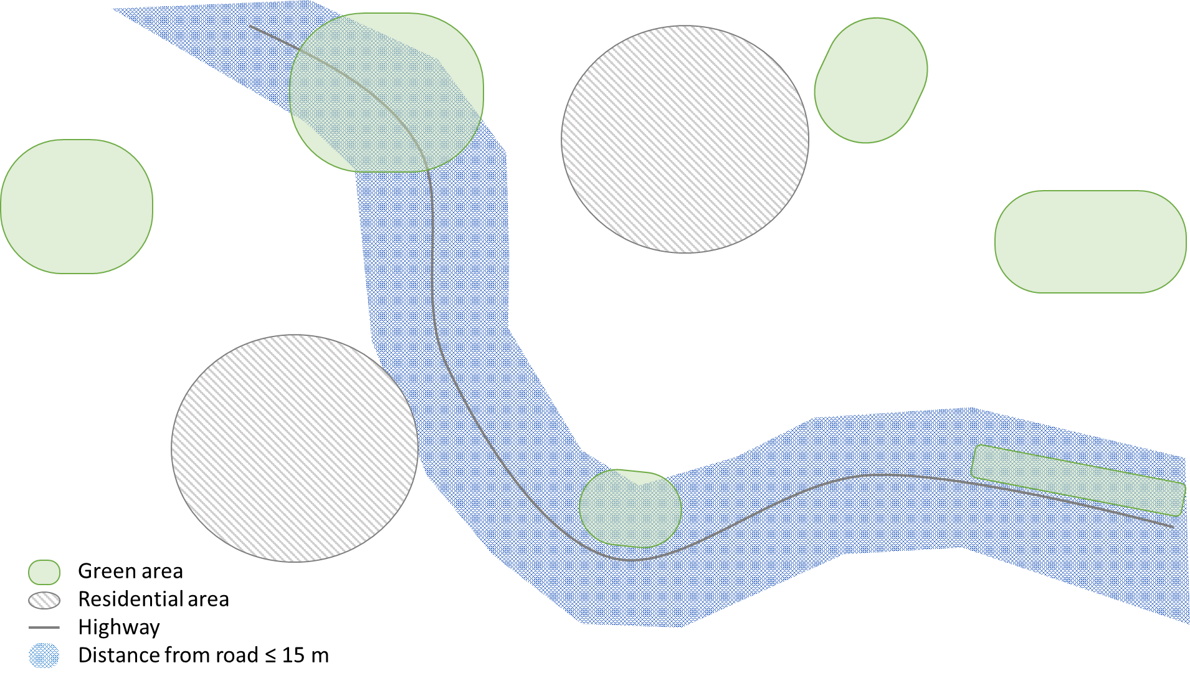
Figure 1: A schematic example of classification of green areas into those that are located within 15 metres from a highway versus those that are not located close to highways, using buffer analysis.

Example 2: Filtering of green areas in terms of their area or vegetation height
CityGML allows defining a vegetation type for PlantCover objects by using the Class attribute [4]. GreenTwins has extended this basic functionality of CityGML to the point that it is possible to define vegetation both generally in terms of a habitat type (for either planned green areas, or existing green areas that are not inventoried in detail) and by describing their species and the species’ relative covers for three vegetation layers: trees, bushes/shrubs and underground vegetation (for green areas that have been inventoried either in the field or by using remote sensing methods). Additionally, the GreenTwins Species database contains an estimate for mature age and height and canopy dimensions for each species, and the GreenTwins Habitat type database describes default vegetation for each habitat type. Therefore, it is possible to roughly estimate vegetation height for green areas, either based on their defined habitat type, or based on their defined (inventoried) vegetation. Spatial analysis can be used to identify those green areas that meet either specific area or width requirements.

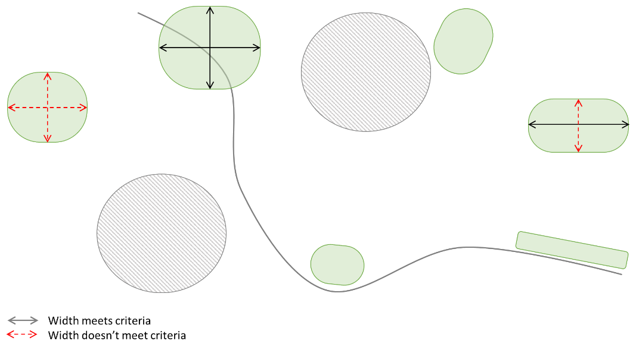
Figure 2: A schematic example of identification of green areas that meet the criterial of a certain minimum width in at least two perpendicular dimensions.

Example 3: Filtering of green areas belong to specific habitat types
CityGML allows defining a vegetation type for PlantCover objects. GreenTwins has extended this feature by creating a hierarchical habitat type classification for PlantCover objects. It is possible to use the hierarchical habitat type classifications to filter green areas that e.g. serve as pollinator habitats.

Examples of semi-automatic generation of Regional Green Factor layers from GreenTwins vegetation re data

Biodiversity layers (K1-K10)
Green Area Factor layer | New layer type needed | Filtering criteria to existing data | Needed additions to object atrributes | Spatial calculation
K1 and K2: connectivity estimation  Green areas that contain biodiversity values receive different Green Factor values depending on whether they are connected elements in the green area network, or isolated from it. |  |  |  | GreenTwins applications for analysis could include distance calculations that determine connectedness vs. isolatedness either depending on  - simple heuristics, such as minimum distance to other green areas that fulfil certain criteria, or  - connectivity estimates calculated for an area from the perspective of the entire habitat network [5].

Noise control (K11-K17)
Green Area Factor layer | New layer type needed | Filtering criteria to existing data | Needed additions to object attributes | Spatial calculation
K12 Vegetated areas with permeable soils |  | This layer includes vegetated areas where the soil is permeable, e.g. forests, meadows, roadside vegetation. Simple filtering of green areas based on their habitat type or function could be used to create a list of accepted green area types. |  | This layer includes green areas that are located nearby noise sources. In a GreenTwins analytics application, areas with noise could be determined either from  - city noise data layers [6],  - conducting noise calculations using simple heuristics, or  - buffer analysis from known noise sources, e.g. highways.
K13 Forested area, with at least >15 m width |  | This layer could include green areas that are either classified into forested habitat types, or green areas with ≥ 50 % tree cover. |  | This layer contains green areas located between noise sources, such as highways, and e.g. residential areas. Analysis of roads and residential areas (land use) & calculation of at least 15m width of the green area meeting the criteria between these two.

Stormwater management
Green Area Factor layer | New layer type needed | Filtering criteria to existing data | Needed additions to object atrributes | Spatial calculation
K20 Vegetated temporary flooded meadows |  |  |  | This layer contains green areas that are located next to water elements, and contain a lowered topography that can temporarily retain water. Thus, potential sites could be analysed using distance analysis from brooks and rivers, and topography analysis.

Microclimate management
Green Area Factor layer | New layer type needed | Filtering criteria to existing data | Needed additions to object atrributes | Spatial calculation
K24 Multi-layered vegetation |  | This layer contains green areas that contain vegetation in three layers: underground vegetation, bushes and trees. Green areas could be classified into this layer in case  - their vegetation is individually defined, and  - vegetation cover exceeds e.g. >30 % for all three layers.

Pollination
Green Area Factor layer | New layer type needed | Filtering criteria to existing data | Needed additions to object atrributes | Spatial calculation
K29 Core network for pollinators |  | This layer  chould filter those green areas that have been classified into habitat types that are known to support pollinators, e.g. meadows and open ruderal areas. |  | This layer includes sites that belong to a pollinator network. See the examples provided for Biodiversity layers for examples of how the connectedness or isolatedness could be calculated for certain habitat types.

Recreation
Green Area Factor layer | New layer type needed | Filtering criteria to existing data | Needed additions to object atrributes | Spatial calculation
K33 Forested areas generating a ‘forest feeling’ |  | This layer includes green areas classified as forests, or with tree cover exceeding a certain threshold, e.g. 30 %. |  | This layer includes green areas whose width exceeds 200 m in two perpendicular directions, and for which the total area is between 4-5 hectares.

References
[1] Alueellinen viherkerroin 2.0 – opas ekologisen kaupunkisuunnittelun tueksi - Fiksu Kalasatama
[2] Lippus: Uus linnaplaneerimise tööriist „rohefaktor“ aitab linna tuua elurikkust ja vältida kuumasaarte tekkimist – Pealinn.ee
[3] OGC City Geography Markup Language (CityGML) En-coding Standard
[4] www.sig3d.org/codelists/citygml/2.0/vegetation/2.0/PlantCover_class.xml
[5] https://journals.sagepub.com/doi/abs/10.1177/0309133315598713
[6] Noise study | City of Helsinki

