

Instructions for creating textures and billboard images for the GreenTwins plant library

Introduction
This document provides guidance for photographers and image processers for preparing textures for digital plants and biomes for the GreenTwins plant library. It is advisable that everyone working with texture creation read the chapter Texture use in the GreenTwins plant library before planning their activities on texture creation. Specific instructions for Photography and Image processing follow in their respective chapters.

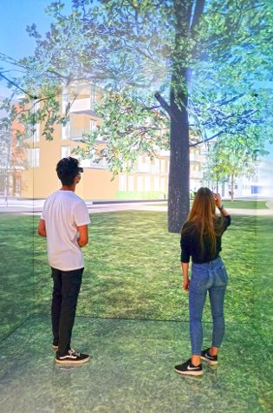

Texture use in the GreenTwins plant library
The GreenTwins plant library consists of two types of digital vegetation objects: individual plants and green areas. Larger plants, such that are planned and maintained individually in an urban plan, e.g. street trees, are modelled as individual plants. Other vegetation, e.g. herbaceous plants, small shrubs and any spontaneously growing vegetation of ruderal areas, are typically modelled as part of green areas. The 3D modelling workflow for both object types is described below to give context on how the created textures will be used in GreenTwins.

Fig. 1: Virtual greenery. Photo: GreenTwins

A. Individual plants

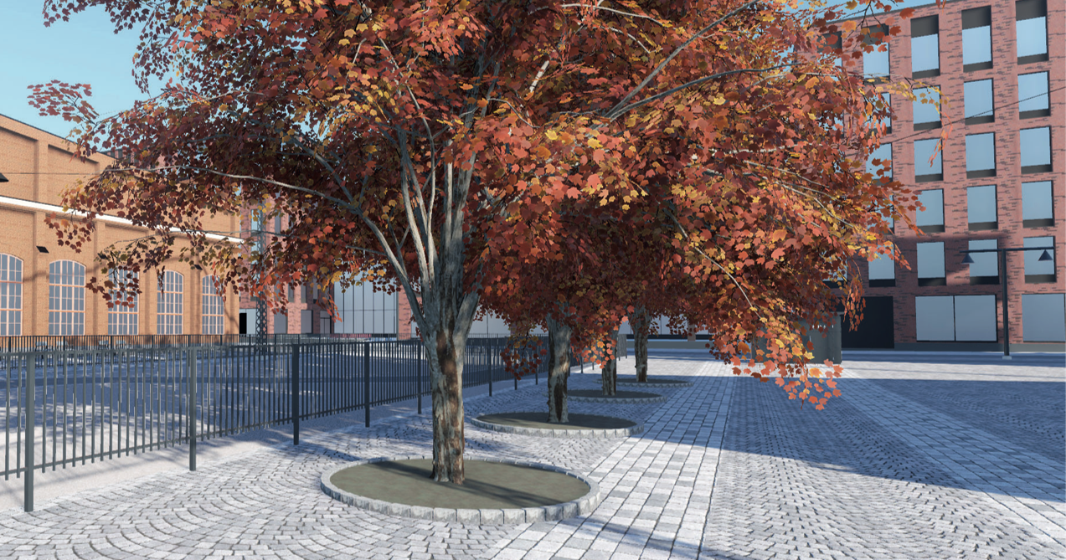
Fig. 2: 3D tree models used in a Virtual Reality application. Photo: DesFennica Oy

Plants in the GreenTwins plant library are prepared algorithmically. 3D objects representing different age versions of different individuals of the species are created computationally from a species-specific parameter file (that defines the general 3D branch structure and growth of the species) and bark and leaf (and possible flower/fruit/cone) textures. The created 3D objects consist of a polygon mesh, i.e. interconnected polygons that together create a seamless surface for a 3D plant object. Each vert on the plant object’s surface contains UV coordinates that instruct 3D viewers and game engines on how a texture should be projected onto the model to visualise the object,(Fig. 2)
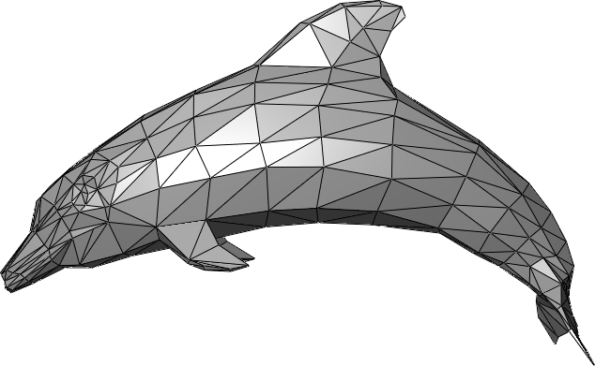 | 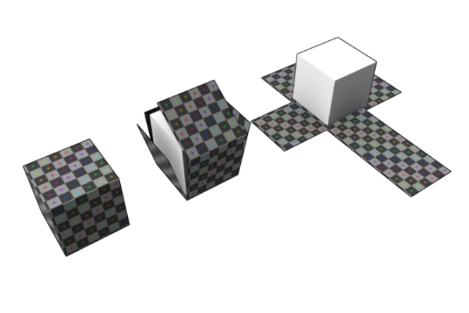
Fig. 3: A 3D object consisting of a seamless polygon triangle mesh (left). Textures are mapped on 3D objects by UV coordinates (right). Each polygon surface (here, faces of the cube) contains UV coordinates that define which positions of the texture file are attached to which corner of the surface.
(left image: Chrschn at Wikipedia. Right image: Zephyris at Wikipedia, license: CC BY-SA 3.0).

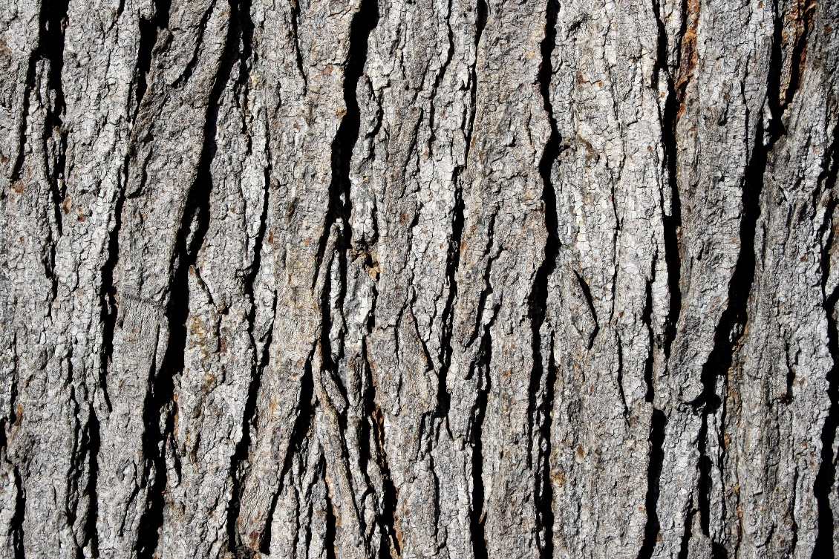
Fig. 4: Tree bark texture at Photos-Public-Domain.com shared with a CC0 licence.
Bark textures: Trunk and branches of a digital plant are textured by repeating a bark texture around and along the branches of the plant. The 3D algorithm calculates from branch thickness whether the branch texture will be tiled once, twice, or multiple times when wrapping the texture seamlessly around the branch. By default, bark texture is intended to cover half the circumference of the branch, and therefore, by default the texture is tiled twice around the branch. However, to avoid stretching or compressing the texture in thicker or thinner branches, the number of wraps may be automatically increased or reduced
Example: Seamless, wrapped tree bark textures in Unreal Engine
Example: Tileable tree bark texture that can be rotated

The algorithm aims at retaining the 1:4 aspect ratio of GreenTwins bark textures when tiling the bark texture along the length of the branch. The number of times the bark texture is tiled along the branch can therefore be counted as branch length / (4 * branch circumference / number of texture copies tiled around the branch). NOTE: Whereas there are always a whole number of texture copies around the branch, the number of texture copies along the branch may be something else than a whole number.

If the modelled species has different bark types for different age versions or branch sizes (as is the case e.g. for some trees’ trunks versus smaller branches), the plant’s parameter file defines different bark textures to be used for defined age versions or branch sizes. The algorithm wraps bark textures twice around the largest branches on which the bark type is intended to be used.
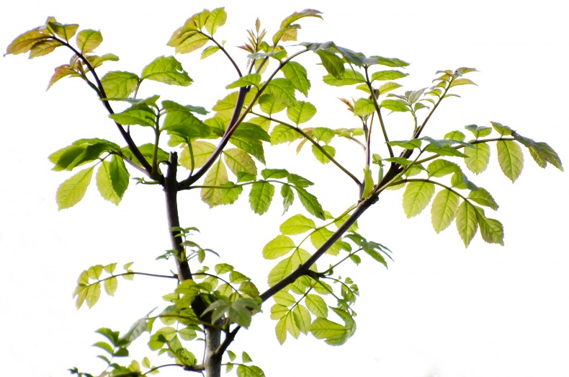  Fig. 5: Green Leaves And Branches Free Stock Photo - Public Domain Pictures, shared under CC0 1.0 license.  Another example: 3D twigs of the birch tree in The Grove tree models. | 3D twigs and texture atlases: Large plants, such as trees, have large numbers of small branches with attached leaves or needles that create the tree canopy. To reduce the complexity of plant 3D models, small branches and leaves are not modelled individually. Instead, the 3D structure of small branches and leaves that is typical to the species is hand-modelled and saved as 3D twigs. When visualising the 3D plant, the 3D twig is attached repeatedly all over the tree’s branch structure, to create the feeling of a canopy.
Example: Rowan leaf texture atlas against a transparent background at RAWcatalog.com
Branches of the 3D twig are textured using the branch texture (that has been defined as appropriate for the branch size) for the plant. The 3D twig is populated by a variety of different leaf images typical to the species from a leaf texture atlas. A leaf texture atlas is an image that contains various leaf images in the same image at pre-defined locations. The GreenTwins algorithm picks leaves from their dedicated locations in the texture file. Seasonal effects of e.g. autumn leaves and leafless periods are created by software.
Example: Leaf and needle twig texture atlases in textures.com
Flowers, fruits and cones: GreenTwins plants can display flowers, fruits or cones as seasonal effects. Flowers, fruits and cones are shown as flat, two-dimensional images that display the flower or cone from its most recognisable or typical viewing angle. Flower and cone images function as billboards, i.e. they automatically turn towards the viewer.
Example: Billboard images of a tree in She et al. (2017)

B. Green areas
Green areas are polygon-shaped areas in a landscape for which species composition and vegetation height is defined, but each plant’s location is not defined individually. Green area visualisations are constructed from textured ground surfaces, billboard images of herbaceous plants, and 3D models of large plants (from the library of individual plants), as needed by the green area. For instance, rocky surfaces with small green plants may be visualised using a surface texture and billboard images of grass, whereas mixed forests of ruderal areas are visualised using also 3D models of trees. Green areas are visualised with four seasons. Seasonal effects of 3D models of large plants are created by software as for individual trees, whereas seasonal effects of herbaceous plants are created by using four different seasonal versions of the plant image.
Example: Green Area Biomes in Unreal Engine

Texture types
Textures are not only used in 3D objects to convey colour, but multiple other types of textures exist as well. GreenTwins 3D objects will also utilise opacity maps, which define transparency levels of the texture (e.g. fully transparent backgrounds), and normal maps, which convey information on light reflection from the texture surface. This allows the creation of detailed surface topographies to 3D objects without high computational workload.

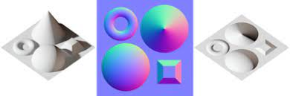 | Example: Textures with normal maps  Figure 2: A three-dimensional shape (left) and a normal map that aims to create a sense of similar three-dimensionality (right; source: Wikipedia under lic. CC BY 4.0).

Instructions for texture photography
General instructions: Always aim at taking photographs in lighting that results in uniform luminosity and contrast in the image. Avoid strong shadows, reflections or highlights in the photographed area. Take photographs in a perpendicular angle to the photographed object. Provide images in their original raw format.

Bark textures: In this context, bark refers to a branch surface, regardless whether the surface is woody bark or not. The photograph intended to be developed into a bark texture should cover the (a) width of half of circumference of the photographed branch, and (b) the height of four times the width of the half-of-circumference along the plant stem, to result in a picture with a 1:4 rectangular aspect ratio. This can be done in two ways. Non-destructive method: Photograph the branch from three angles, from the same height, so that the three photographs together cover half the circumference of the branch. Ensure that the three photographs can be combined and straightened into a single photo using image processing software. Destructive method: Remove and flatten half of the circumference of the bark on a white (or otherwise contrasting) surface for photography.

Figure 3: Half of the circumference of a cylindric object, such as a plant branch, cannot be photographed as a single image. Therefore, several photographs and image processing are required to create a uniform image where the targeted area appears as a flat surface.

If the photographed plant has several distinct bark textures either along the plant, or during different ages of plant growth (e.g. Betula pendula), coordinator of texture creation (e.g. a landscape architect) should provide instructions for how many branch types should be photographed. Choose average-aged/sized plants of the targeted age class for texture photography. NOTE: The same texture(s) will be tiled around and along branches, and used in multiple 3D tree models of the species that may be placed next to each other in 3D models, so the texture cannot be taken from a particularly distinctive part of the bark. Aim at a very typical image of the branch surface.

Final textures will be resized into 512 px (width) x 2048 px (height) rectangles. However, it is useful to aim at highest practical resolution in the photography phase, as higher-resolution images can be stored for later use and for the generation of e.g. normal maps (see Texture types). Texture resolution can be reduced to the desired size later on using image processing software. It is also advisable to take 2-3 variants of the same species’ bark (e.g. from nearby trees or from different heights of the tree), but this is not mandatory.

Leaves: Photograph 3-5 leaves of the plant on a flat white (or an otherwise contrasting colour relative to the photographed object, so that the leaf background can be distinguished and set transparent in the image processing phase) surface. Ensure that the leaves are straight and flattened (e.g. by using a glass plate on top), typical to the species but varying from each other, and there are no unnecessary empty margins between or on the sides of the leaves. Photograph the leaves also from the bottom surface, ensuring that leaves remain on same locations as in the front side image. The desired size for the leaf collage photos is ~2048 px x 2048 px altogether, but the exact sizes are not that strict, since the images will be combined into a leaf texture atlas later on. Indicate the scale of the leaves either in the image or outside of it, so that relative size differences in leaves of different species can be considered when creating the 3D twigs. For instance, the scale can be on one side of the image.

Example: Placing leaves next to a ruler for measurement (Harvard.edu)

Twigs with leaves/needles: Photographs of twigs with leaves/needles are used mainly to understand the typical 3D shape of branch tips in the species for the modelling of the 3D twigs. For deciduous plants, choose two ~0.5 m long twigs (small branches at the furthermost part of the branch structure where leaves are attached). For coniferous plants, photograph “hand-sized" or otherwise suitable-sized (for the species) subsections of the twig. Photograph the twig against a white (or suitable contrasting colour) canvas by hanging the branch in its typical hanging angle. Photograph from both sides, from up, and from the front. For deciduous plants, take all the four photos from instructed angles first with leaves, then remove leaves from the twigs and photograph again.
Flower/fruit/cone texture atlases: Flowers, fruits and cones are photographed from an angle that displays the target from its most recognisable or typical viewing angle: (1) Circular-shaped flowers and fruits, e.g. S. aucuparia berry bunches, are photographed from a 30° angle relative to the symmetric centre of the object, (2) Cones, elongated shapes and elements that hang vertically in the plant (e.g. S. vulgaris flowers) are photographed straight from the side. The result should generally be a 2048 px x 2048 px image, but for very small flowers, e.g. M. domestica, image size can be smaller than this. The coordinator of texture creation (e.g. a landscape architect) should define which seasonal variants (e.g. flowers or fruits) should be photographed for each species. Other seasons’ variants might be made with software.
Example: Rowan Berry Against White Background Stock Photo

Herbaceous plants: Herbaceous plants photographed for the visualisation of green area biomes should be photographed ideally in three life stages, i.e. in their spring, summer and autumn versions typical to the species, though this may not always be possible due to time constraints. For each season, photograph 2-3 typical individuals of the species. Depending on the size of the photographed plant, either place a background canvas made of a uniform contrasting colour behind the plant, or take the individual to be photographed against a contrasting colour surface elsewhere. Add a scale to the image.

In case of a missing spring version of the plant, either the photographer or the coordinator of texture creator (e.g. the landscape architect) should describe differences of the spring version relative to the summer version in (a) relative size, and in (b) structural elements and (c) potentially different RGB colours that are included or missing relative to the summer version. In case of a missing autumn version of the plant, the dominant RGB colour(s) of the plant in the autumn should be defined. For instance, for V. myrtillus, record the autumn colour of both leaves and berries. Additionally, dates for the transition between spring, summer and autumn versions for the plant should be recorded.

Instructions for image processing
General instructions: The resulting images should be stored in a lossless format, e.g. PNG. If the images have been modified using an image processing software, also the original software specific file formats of the texture, e.g. .psd, should be delivered for later use.

Bark textures: Adjust the bark texture resolution to a 512 px (width) x 2048 px (height) (or twice as much, 1024 px x 4096 px) rectangle. (It is important for fast image rendering that texture resolutions are exactly power-of-two numbers at both dimensions, i.e. 2⁹ = 512.) Adjust contrast, lighting and colour balance so that their overall levels are uniform throughout the texture. Remove any possible empty cells or margins at the sides of the texture.

Bark texture should be made seamless at both horizontal and vertical edges. This allows the texture to be wrapped (a) two or more times around the plant stem without marked discontinuities, (b) two or more times along the plant stem for long branches. The texture can be made seamless for instance by first offsetting the image so that the “seam” between the top and bottom (or right and left) edges is moved towards the centre of the image, after which the image is modified as needed to make the seam unnoticeable. An example of a textured tree bark with a displacement map and seamless edges: Bark of an oak tree - seamless 3D texture presentation - YouTube.
Example: Making seamless textures | potter1992 (wordpress.com)

Leaf images: Rearrange leaves of the photographed leaf collage so that leaf positions match the GreenTwins coordinate template for leaf atlases. Use the scale in the leaf collage image (or other source data) to determine the real size of leaves and adjust leaf sizes in the coordinate template according to the size of the leaves relative to the intended maximum sizes of the texture atlas. In case of asymmetrical leaves, mirror the leaves in the bottom side photographs to place both sides of the same leaf into the same position in the coordinate template. The result should be a leaf 2048 px x 2048 px texture atlas that contains both sides of each leaf. Define an alpha channel for transparent regions of the leaf texture. Using available data on RGB colours of spring and autumn leaves, create spring and autumn versions of leave images. Dogear leaves for the spring will be created with software.

Flower/cone texture atlases: Remove any unnecessary empty margins from the image. Define an alpha channel for transparent regions around the object texture. If needed, use available data on structural details, relative sizes and RGB colours of seasonal variants to create the needed seasonal variants of the object. The result should be 2048 x 2048 px images, but for very small flowers, e.g. M. domestica, image width and height can be a smaller power-of-two number.

Herbaceous plants: Remove any unnecessary empty margins from the image. Define an alpha channel for transparent regions around the object texture (normal map). If needed, use available data on structural details, relative sizes and RGB colours of seasonal variants to create the needed seasonal variants of the object. The result should be 2048 px x 2048 px images.

Making of displacement maps (future extension): Render the high-resolution image of a texture into a black & white image. Determine contour depths based on resulting colours (see Displacement mapping - Wikipedia). Create displacement maps for bark topographies, and for leaf stem/petiole topographies.

Key insights regarding creation of plant textures and plant models: lessons from the GreenTwins project
Image and Texture Quality: Maintain separate high-resolution original images and ready-to-use textures. Keep a repository of original textures; they might become more valuable in future due to the increasing quality of rendering technology.

Recreation of Textures: Understand that recreating useful textures can be done relatively easily given the right conditions. To facilitate this, save the high quality material in a consistent way.

Looping Textures and Seamless Integration: For looping textures, consider making them seamless through Photoshop using a low-effort offset method. A helpful guide can be found at this link: https://www.youtube.com/watch?v=FR3Z0zr1RaY.

Lighting for Looping Textures: Exercise caution to eliminate low-frequency lighting changes when creating looping textures.

Texture Lighting: Aim for normalized lighting conditions between different species and samples to achieve consistent quality. This can be accomplished by either using studio-like conditions for the photos or adjusting them in photoshop

Larger Plant Modeling: For larger plants, consider mapping the image to simple, non-planar geometry for a more realistic appearance (similar to GT LOD1 twigs with added vertices). Nevertheless, ensure that the textures are still applicable for planar use. The chosen technique may affect this: some libraries generate planar geometry with minimal computational cost while others create multiple complex geometries with minor additional GPU cost.

Smaller Plant Modeling: Most smaller plants are represented by only a few pixels in most cases. Increasing the albedo texture size doesn't necessarily add extra detail. Make the most of your efforts by synthesizing additional textures like glossiness and normals. Note, however, that this requires a comprehensive understanding of the rendering process.

Texture Transparency: Most critical lesson from GT is to ensure that significantly less than 50% of the texture comprises transparent pixels. In distance, the engine samples only a few pixels per texture; if most pixels are alpha 0, the geometry practically disappears when in fact at least some plant-colored fill would be preferable.

High Aspect Ratio Plants: For long, narrow plants, consider incorporating several plant individuals within the same texture. Replicates of the same plant can be used, especially if you vary the directions and mimic different lighting conditions using normal maps. Consider creating a few variations of plant groups, even when using the same images as a starting point.

Texture Compression: Understand that Unity and many other 3D engines compress textures as squares. However, given the reasons stated earlier, prioritize having more than 50% fill over square geometry.

Understanding Shaders: Before embarking on texture or plant modeling, secure at least a basic understanding of how the shaders of the 3D engine work. This knowledge is critical when considering the movement of plants in response to environmental factors like wind. The parameteres controlling the behaviour is typically encoded into the vertices or custom textures, preferably during the initial modeling phase. As plant models often consist of multiple copies of the same plant part (such as twig), it might be a lot of work to add this information afterwards.

Realistic Rendering Techniques: Shaders also play a key role in applying sophisticated rendering techniques, such as simulated subsurface scattering for translucent materials like leaves, or wetness effects for portraying rain or dew. Often, these effects are driven by a set of synthesized textures.

Please note that these suggestions may be subjective and largely dependent on personal preference and the details of the tech chosen for use. Nevertheless, they should provide insights, particularly in discussions where plant modeling expertise may be lacking.

Tips for the 3D modelling of twigs using Blender
Clear animation data on layers
- In Blender, view Scene Collection

Check object face direction
- (Viewport shading => Solid for view in polygons)
- Edit mode (Tab)
- Show orientation (Show Overlays => Face orientation)
- Show normals (Edit mode > Show overlays > Normals > Show normals)
- Select the objects that need to be flipped (select > select linked with Ctrl + L if needed)
- Flip normals (Alt + N > Flip).

Combine leaf objects into one mesh
- Select by material (Object mode > Select linked > Material)
- Deselect parts if needed (Shift + select)
- Select one of the leaves as the root of joining (Shift + select)
- Ctrl + J to join leaves (result can be seen in the right hand menu)

Check alpha/opacity mapping for transparency
- Go to Shader Editor (bottom pane) > Select the map linked to Alpha > Ensure that it is connected to the opacity map (Browse image > Select)
- Connect color information to Alpha (drag new connector line)

Fix full metallicity
- Go to Shader Editor (bottom pane) > edit Metallicity value of the main menu

Check rendering order
- Material properties (second-lowest at the right hand pane) > Settings > Blend mode > Alpha Clip

Correct twig direction
- GT twigs need to start from origo and face towards the -Y axis
- Rotate the twig starting point (gizmo) towards -Y (R)
- Move the origin of rotation if necessary (Options in the top right menu > Origins)
- Move to the axis (G)

Reduce polygons of the finalized object as needed
- Select object/leaf group
- Go to Edit mode
- Mesh > Clean up > Decimate Geometry

Check the finalized twig in GLTF viewer/editor
- Google "GLTF editor" etc., multiple free options can be found

List of produced texture files
Default textures for GreenTwins species:
File type | Description | LoD0 | LoD1 | Naming convention
Trunk texture |  | X | X | [Species_name]_trunk (*)
Large branch texture | (Used for species for which the texture of large branches should differ from the tree trunk, e.g. Betula pendula) | X | X | [Species_name]_large_branch (*)
Leaf texture atlas |  | X |  | [Species_name]_LoD0_leaves (*)
Small branch texture |  | X |  | [Species_name]_LoD0_small_branch (*)
High-polygon twig 3D shape | Twig branches should have a pentagon profile and include ~4 polygons per leaf (depending on leaf size). The overall polygon count for the twig should be ~100. The 3D shape should have two-faced texturing. | X |  | [Species_name]_LoD0_twig
Twig texture | The combined texture of leaves and branches for LoD1. |  | X | [Species_name]_LoD1_twig (*)
Low-polygon twig 3D shape | The 3D shape should have two-faced texturing. |  | X | [Species_name]_LoD1_twig

Additional guidelines for naming textures:
- Species files are named by their two-part scientific names, e.g. files for Scots pine are named as Pinus sylvestris. If a specific texture is created for a species cultivar, sub-species or variant, the whole scientific name of the cultivar/sub-species/variant should be given as the name.
- In case there is a need to produce multiple texture files of the same type for a species (example: For Scots pine aka Pinus sylvestris, different trunk textures maybe created for lower and upper parts of the trunk), each file should be either numeric indices (e.g. [texture_name]_01, [texture_name]_02) or descriptive names (e.g. [texture_name]_dark, [texture_name]_light) should be given to each texture variant before the texture file type appendices (see below).
- For each texture file (*), at least the following three files should be produced:
- Colour texture file, containing RGB colours of the texture (defined preferably in the range 0-255). Colour texture files should be name using syntax “[texture_name]_colour”.
- Opacity file, defining transparency levels (defined preferably in the range 0-255). Opacity texture files should be name using syntax “[texture_name]_opacity”.
- Normal map defines tangent directions for each object fragment (defined in pixels depending on the map resolution), using the OpenGL style (LearnOpenGL - Normal Mapping). Normal map files should be name using syntax “[texture_name]_normal”.
Example of a texture file name: “Acer_platanoides_trunk_normal.png”.
Twig shapes should be designed with the gizmo at origo, and designed so that the 3D shapes are oriented along the horizontal xz plane.


FinEst Centre for Smart Cities.

Deciduous means "falling off at maturity" or "tending to fall off," and it is typically used to refer to trees or shrubs that lose their leaves seasonally (most commonly during fall) and to the shedding of other plant structures such as petals after flowering or fruit when ripe. https://worldoffloweringplants.com/deciduous-plant/

